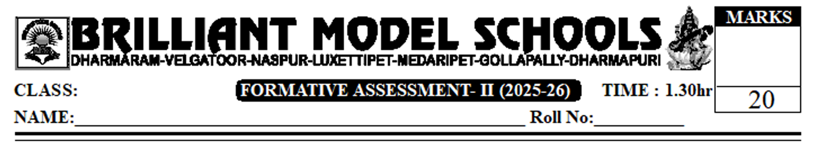

VI Social

I. Answer the following questions. 2x2=4
1. List out various means of living in a Hill region?
2. Why Early humans not wear cotton and woollen clothes?
II. Answer the following questions. 2x3=6
3. A) compare the tools used by the Early Humans with those of modern times?. (or)
B) What is Rythu Bazaar? what are its benefits and limitations?
4. A) Do you think it is necessary for the Government to fix a single price for paddy? (or)
B) If there was no stone and not grinding stone How would it affect our food?.
III. Read the following passage and Answer the following questions?
"paddy cultivated in Telangana is mostly sold in the markets and farmers keep only a small share for their own use. A considerable amount of paddy produced by small farmers like SHANTI is used for their own consumption. Large farmers sell most of their produce in the markets.
Telangana farmers sell nearly three-fourths of their harvests within the village and one-fourths in AMY. Big farmers sell their harvest in AMYs. They own vehicles like tractors which reduce their transportation expenses."
Answer the following questions. 4x1=4
1. What is AMY?
2. How is paddy sold in yard.
3. Where do big farmers sell their paddy?
4. Why do big farmers sell in AMYs?
IV. Map Pointing. 4x1/2=2
1. Locate the following parts.
a) Goa b) West Bengal c)Tamil Nadu D) Patna.
PART - B.
V. Choose the correct answer. 8x1/2 = 4
- Koya means________ ( )
A) A good person living on the hills.
B) A person that lives in forests.
C) A gardener that lives in gardens.
D) A civilized person.

- An example for microliths_________________.
A) stone sickle B) Early stone C) heavy stone tools D) cutters
- Who cultivates only one crop?
A) Ravi B) Ramu C) Ravi and Ramu D) Ravi and Vijay kumar.
- Weekly market is called
A) Rythu Bazaar B) Retail market C) wholesale market D) Santhalu.
5. The day of Santha is Kuttangur.
A) Sunday B) Monday C) Tuesday D) Saturday.
6. Big Farmers sell paddy in
A) SHGs B) AMYs C) Landlords D) Bookers
7. M.S.P abbreviation.
A) Agriculture market yard. B) Antyo daya monthly yojana. C) Agriculture market yojana.
8. The Early people used the tools made up of?
A) Sand B) Neoliths C) Steel D) Bronze.

